**Employee.java**

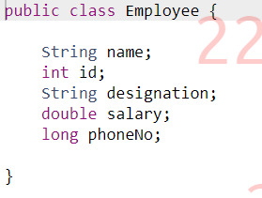

**Driver.java**

**Command1.sh**

**Command2.sh**

